**MEMORANDUM**

**DATE:** 03/23/21

**TO:** Art O’Leary, LMC

**FROM:** Stephen Peacock, Certified Arborist PN-0525A

**RE:** Rockwood 10 Gresham, OR

I arrived on site at 8 am and met with Pete to review excavation plan for the meandering sidewalk through the Douglas fir grove. While peeling the grass layer off, we ran into only two surface roots of 2-4” diameter. Work was stopped because the plan called for the excavation to be too deep.

Stephen Peacock, Certified Arborist PN0525

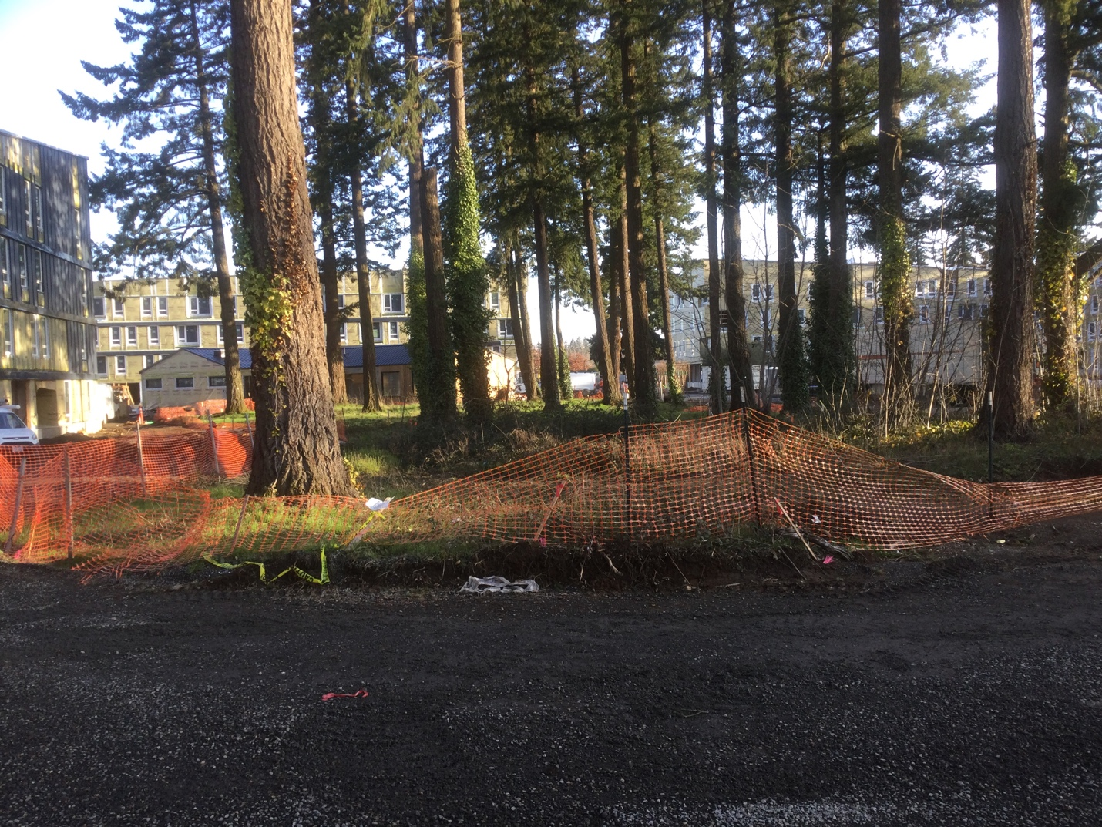

Site as of 3/23/21